Name MiddleInitial. FamilyName
Current Position
University/Institution, Acronym

1. Education and Training

Year | Title or Activity | Institution
19XX | Bachelor in … / Master in … / Ph.D. in … | University
19XX-20YY | Postdoctoral Fellow /  Visiting Professor

2. Professional History

Period | Position | Institution
19XX−20XX | Assistant / Associate / Full | University

3. Most Relevant Scientific Results

Articles
- A. Author, B. Author, Journal, Vol, Page (Year)
- A. Author, B. Author, Journal, Vol, Page (Year)

Book Chapter
- A. Author, B. Author, Name of the Chapter, in Book, Page (Publisher, Year)
- A. Author, B. Author, Name of the Chapter, in Book, Page (Publisher, Year)

Patents
- A. Author, B. Author, Name of Patent, filed at/granted by (Year)
- A. Author, B. Author, Name of Patent, filed at/granted by (Year)

Registered Software
- A. Author, B. Author, Software (Year)
- A. Author, B. Author, Software (Year)

4. Current Research Grants

- Project Name A
  - Coordinator: x
  - Resources: x
  - Duration: x
  - Funding Agency: x
- Project Name B
  - Coordinator: x
  - Resources: x
  - Duration: x
  - Funding Agency: x
- Fellowship A
  - Funding Agency: x
  - Type: x
  - Level: x
  - Duration: x

5. Current Supervisions

Level | Project | Agency
Undergraduate /Master/Ph.D.

6. Academic Quantitative Indicators

Item | Total
Books
Publications in Refereed Journals
Book Chapters
Supervised Master’s Dissertations
Supervised Ph.D. Thesis

7. Other Biographical Information

Activity | Period
Committee / Association / etc. | 2006-20XX-
INTRUCTIONS

Should not exceed 3 pages
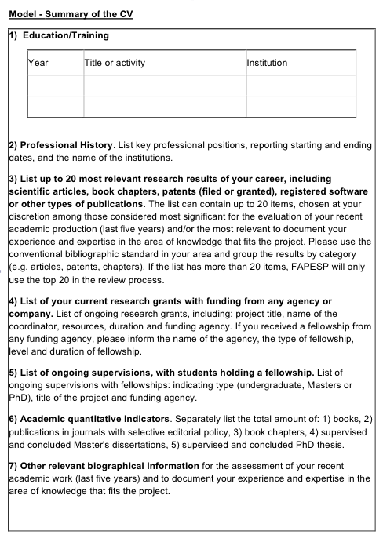
All sections must be completed – even with “Nothing to Declare”

